SECTION A – MULTIPLE CHOICE

1. Long-stemmed pea plants were crossed with short-stemmed pea plants. All the offspring

were long-stemmed plants

The genotypes of the offspring plants are:

a. either homozygous dominant or heterozygous

b. heterozygous only

c. homozygous dominant only

d homozygous recessive only

2. Recombination occurs during :

a. anaphase of the second meiotic division, as chromosomes separate

b. metaphase of the first meiotic division, as chromosomes are paired

c. interphase as chromosomes are replicated

d. telophase of the first meiotic division, when cytoplasm is divided into two parts

3. Which of the following is NOT a significant source of variation in humans?

a. Random fertilization

b. DNA replication

c. Recombination

d. Non-identical parents

4. Fragile-X syndrome is caused by a single gene defect of the FMR1 gene on the X chromosome, causing mental retardation.

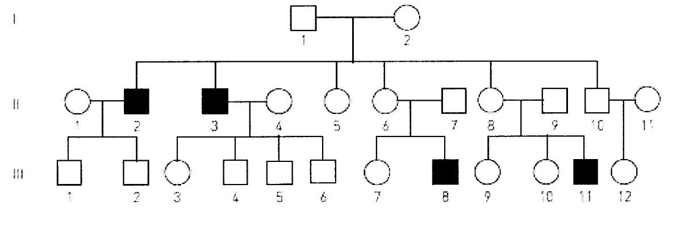

Using the pedigree shown, which one of the following combinations of genotypes is possible for the individuals listed?

a. I 2: XF Xf, II 4: XF Xf, III 6: XF Y

b. I 2: XF Xf, II 4: XF XF, III 6: Xf Y

c. I 2: XF XF, II 4: XF XF, III 6: XF Y

d. I 2: Xf Xf II 4: XF Xf, III 6: Xf Y

5. In regards to sex determination, which statement is correct?

a. A zygote with X and Y chromosomes will develop into a female.

b. Two X chromosome ova can fuse to develop into a female with XX chromosomes.

c. Half of all ova have X chromosomes, while the other half have Y chromosomes.

d. Usually, half of all sperm have X chromosomes, while the other half have Y chromosomes.

6. A haemophiliac man and a non-haemophiliac woman, who comes from a family with no history of haemophilia, have a daughter.

Which probability matches this circumstance?

a. There is a 50% chance the daughter has haemophilia

b. There is a 100% chance the daughter is a carrier

c. There is a 50% chance the daughter is homozygous dominant

d. There is a 100% chance the daughter is homozygous recessive.

7. Non-disjunction producing non-haploid gametes can occur during:

a. the first or second meiotic division.

b. The first meiotic division only.

c. the second meiotic division only

d. mitotic division

8. Fertilization by any particular sperm is:

a. irrelevant because they will all have identical chromosomes.

b. dependant on chromosomes matching

c. controlled by the ovum

d. random

9. Fragile-X syndrome is caused by a single gene defect of the FMR1 gene on the X chromosome causing mental retardation.



From the pedigree above, what is the probability that individual II 5 is a carrier of Fragile-X syndrome?

a. 0

b. 1

c. ½

d. ¼

10. One type of colour blindness is determined by a gene on the X chromosome.

Which of the following lists all the possible genotypes that could result from a cross between individuals with the genotypes Xb Y and XB Xb?

a. XB Y, Xb Y, XB XB, XB Xb

b. XB Y, Xb Y, XB XB

c. XB Yb, XbY, XB Xb, XB XB

d. XB Y, Xb Y, XB Xb, Xb Xb

11. Two parents who are not albino have one child that is albino. The probability that a second child would be albino is:

a. 25%

b. 50%

c. 0%

d. 100%

12. A father with blood type A and a mother with blood type O have children.

The blood types of these children may be:

a. A

b. O

c. A or O

d. A or B

SECTION B – SHORT ANSWER

Write the correct term for the meanings written in the table below.

|  |  |  |
| --- | --- | --- |
| No. | MEANING | TERMINOLOGY |
| 1 | Produce the same characteristic in succeeding generations when bred among themselves | pure breeding |
| 2 | the mating of two organisms – term used in genetics | a cross |
| 3 | the situation where an individual has the same alleles for a particular characteristic | homozygous |
| 4 | gel electrophoresis is used to make a genetic…. | fingerprint or profile |
| 5 | A male gets his Y chromosome from his…? | father |
| 6 | Huntington’s disease shows this type of inheritance… | Dominant  Genetics |
| 7 | Differences between members of a species are called… | variations |
| 8 | Surname of a British geneticist who devised a square to help with his work on heredity. | Punnett |
| 9 | A non-sex chromosome | autosome |
| 10 | Where a person has only one copy of a chromosome, where normally there would be two | monosomy |

11. This diagram represents changes in the numbers of chromosomes during reproduction and growth.

Parents 2n 2n

(x)

Gametes

n n

Zygote (y)

2n

(z)

2n

a. What does 2n represent? diploid number of chromosomes

b. What does n represent? haploid number of chromosomes

c. Identify the process: (x) meiosis

(y) fertilization

(z) mitosis

12. A woman of blood group A claims that a man of blood group AB is the father of her child. A blood test reveals that the child’s blood group is O.

a. Is it possible the woman’s claim is correct? Show working

For the child to be blood group O needs to get an “I” from each parent…i.e.

Child: ii OR as evidenced by the Punnett square below

Woman: IA IA or IA i the man cannot be the father he has no.

|  |  |  |
| --- | --- | --- |
|  | IA | “i” |
| IA | IA IA | IAi |
| **IB** | IA **IB** | **IBi** |
|  |  |  |

Man: IA IB

but the man has no “I” to give,

hence the woman’s claim is incorrect .

b. Could the father of the child have been a group B man? Explain your reasoning.

Yes…If the A group mother is heterozygous for blood group A, and the B blood group man is heterozygous for B group then both will have an I to give, hence it is possible for Blood group B man to have been father of O group child. ii

13. A woman is heterozygous for a sex-linked recessive characteristic. She has children with a man who has the characteristic. What will be the proportion of the genotypes and phenotypes in their offspring?

Show all working

This one is to see that they set everything out correctly, and come up with what the question is asking.

Let recessive characteristic be r

Let dominant characteristic be R

Genotype of mother: XR Xr

Genotype of father: Xr Y

Cross: : XR Xr x Xr Y 1

|  |  |  |  |
| --- | --- | --- | --- |
| Genotype | % | Phenotype | % |
| XR Xr | 25 | Normal, carrier female | 25 |
| Xr Xr | 25 | affected female | 25 |
| XR Y | 25 | Normal male | 25 |
| Xr Y | 25 | affected male | 25 |

|  |  |  |
| --- | --- | --- |
|  | XR | Xr |
| Xr | XR Xr | Xr Xr |
| Y | XR Y | Xr Y |

14.

|  |  |  |  |
| --- | --- | --- | --- |
| NAME | DESCRIPTION | HOW PRODUCE VARIATION | 5 PER PROCESS |
| Random assortment (of chromosomes during meiosis) | during meiosis chromosomes move to either pole of the cell – which one they go to does not influence which one another chromosome goes to | As chromosomes are randomly sorted, therefore genes and characteristics are mixed, this leads to variation |  |
| Crossing over | chromatids break and reattach to other chromatids during the first division of meiosis | could do a diagram  hence alleles on the chromatid are moved to different chromosomes (same number, different verson), giving a different combination…hence variation |  |
| Non-disjunction | during first and second division of meiosis when chromosome pairs separate…sometimes they don’t…so we can have an extra have 0, 1, 3 chromosomes, in the ovum | hence we get a different to normal no. of chromosomes.  Having differing no. of chromosomes, means different no of genes, and hence characteristics change…i.e. variation |  |
| Mutation | sudden change in the genetic code; or sudden permanent change in DNA/genes | changing bases in DNA changes what the gene is coding for and hence different characteristics result in variation. |  |
| Random fertilization | fertilization occurs in the fallopian tube…the ovum is present – randomly chosen – the sperm is one of millions, hence a random selection | With so much randomness, there will be lots of variation |  |
| Epigenetic factors | altering the expression of a gene without changing gene structure…can be inherited | hence there is the ability to have different characteristics…leading to variation. |  |